**Wills information pack**

**Updated 2019/05/03**

**Dear Reader,**

A will is not something we like to think about, it brings to mind our own mortality and sombre thoughts about the inevitable. But as the good old saying goes; you can be assured of two things in life – death and taxes. We do need to consider the inevitable and ensure that we leave our affairs in good order for those that we leave behind. We have drafted the attached information pack in order to give you some information regarding setting up your will, your estate and how that is to be managed after your death. We have tried to include as much information as possible, hence the length of the document. We have also included some checklists that you can keep with your will to guide you on important documentation/information to keep with your will this will make life easier for your Executor if all relevant information is kept together or noted as to where to obtain all the relevant information.

**Parties to the will:**

* Testator – Male person of the will
* Testatrix – Female person of the will
* Heirs – beneficiaries of the estate
* Guardian – person/s nominated to look after minor children
* Executor – person nominated to manage the estate of the deceased

# **FORMALITIES TO ENSURE YOU HAVE A VALID WILL**

* In South Africa, anybody over the age of 16 can draw up a will, which must be made in writing.
* The Testator/Testatrix and two witnesses should sign your Will on each page and initial next to anything that you may have amended.
* The place and date of signing must be written in at the end of the document.
* Witnesses should be people who have no interest in the Will, and their signatures merely acknowledge that they saw you sign your will. They do not have to know the content of the document. Witnesses CAN NOT inherit in terms of the will.
* Witnesses must be over the age of 14 and of sound mind.

# **EXECUTOR**

* Anyone aged 18 or above can be an executor of your will. There’s no rule against people named in your will as beneficiaries being your executors.
* Many people choose their spouse or civil partner or their children to be an executor. But that doesn’t mean they have to write them out of the will.
* Up to four executors can act at a time, but they all have to act jointly so it might not be practical to appoint that many people.
* The alternate executor is needed if the surviving spouse dies before the testator, or simultaneously or within 30 days of the testator.
* The executor or administrator can also be a professional firm or the director/trustee of a firm.
* You can have a professional executor, but there is no requirement that the executor must be a professional executor like a lawyer or an accountant. It can be a family member. It can be your spouse or a child. They can be assisted by a professional executor and fees can thus be negotiated.
* ACS offers the service of executor, or we can assist the executor in the administration of the deceased estate. In both instances ACS charges, a time based fee, not a % of gross estate fee.
* **What does an Executor do?**
  + Your executor takes on the job of carrying out the instructions you leave in your will when you die.
  + It can be a complicated job even if your instructions and your property are quite simple – it’s not unusual for the process to take several months.
  + The job of an executor is sometimes difficult. For example, they might have to:
    - Decide when to sell your property so that the people who inherit the proceeds get the most money
    - Make sure the right amount of Inheritance Tax, Capital Gains Tax or Income Tax gets paid.

# **GUARDIAN:**

* In the event that you have minor children, a guardian should be nominated in your will.
* Nominating a guardian does not make that person the legal guardian. That person would still have to be appointed by a court, but at least your family and the court will have an idea of who you had in mind to look after your children when you are no longer around. [*Note: God parent and Guardian are not the same thing. Many people assume because they have asked someone to be a god parent to their child that they will automatically raise the child on their death. This is not the case. A God parent is merely someone who bears witness to a [child's baptism](https://en.wikipedia.org/wiki/Infant_baptism)/christening and then aids in their religious education, as well as their lifelong [spiritual formation](https://en.wikipedia.org/wiki/Spiritual_formation). A guardian is a person who is legally responsible for the care of someone who is unable to manage their own affairs, especially a child whose parents have died.]
* The guardians (appointed by the court) will then be responsible for raising the children.
* Letter of wishes can be used to determine how you would like the children to be raised, what schools you want them to attend, etc. and will provide guidance to the Guardian/s.

# **OTHER IMPORTANT CONSIDERATIONS**

* Remember to review your will on a regular basis, and when there are any changes affecting the will (marriage, children, deaths, change in fortunes, change in legislation, etc.)
* The importance of revising the nominated beneficiaries on policies, retirement funds and your will on a regular basis cannot be underestimated. It is vital to understand that a will does not supersede beneficiary nominations on policies and retirement funds (the Long-Term Insurance Acts overrides the Wills Act). Also, important to note is as follows with regards to **retirement fund** proceeds these will be allocated to those who are currently your dependants; in all instances the trustees of a retirement fund have the authority to override the nominated beneficiaries.
* Ensure that you understand each clause in the drafted document and that the will accurately reflects your wishes.
* It is also important to consider a living will. This document guides the family and doctor at a time when you are no longer able to make decisions about your medical needs (see notes at end of this document)
* Another common mistake is leaving assets to minor children in a will. In South Africa children under the age of 18 cannot inherit assets in their own name. Any assets left to a minor child will go into the Guardian’s Fund – a fund administered by the Master of the High Court. The fund is generally invested in the Money Market and when the child turns 18, he or she can request the Master to pay out the money. We recommend that the best way to deal with Minors in a Will is by way of a Testamentary Trust. The trustees of the Testamentary Trust and guardians, if applicable can be the same, or different. The Trustee control funds for the benefit of the beneficiaries (children)

*NOTE: If youngest heir is younger than 18, testamentary trust is taxed at individual rates

* Consider the situation if all the heirs were also deceased, where should the estate then go to?
* Consider existing suretyships and ensure these are cancelled with the winding up of the estate
* Offshore assets - estate duty is payable on all assets, including off-shore assets. You need to consider the country of the foreign investment, and if a separate will should be drawn up for these assets. It is preferable to have 2 separate wills, just ensure each will specifies it is only dealing with assets of that country.

*Note: foreign assets, earned or inherited before you become resident in SA can be donated free of donations' tax.*

* Collation clause in will - this means that if any heir has already received a payment, this will not be taken into account when dividing up the assets of the estate.
* if testator is VAT registered, the heir will need to be VAT registered, or exit VAT will need to be paid on vatable assets inherited.
* There is ***no transfer duty*** payable on fixed property inherited
* Agricultural property cannot be subdivided, or registered in multiple names
* An asset that has a liability can be bequeathed, subject to the heir settling the debt, but be careful how this is worded, as if the liability is settled before estate duty, then such liability will not be included in the estate duty calculation.
* Shares in companies and members interests in CC's - review the agreements as to how the shares are to be dealt with before you stipulate this in your will. These agreements will override the provisions of the will
* Capital Gains Tax is payable on the gain on any qualifying assets on death.
* Consider the use of usufruct/bare dominium or fide commission in certain circumstances
* Ensure sufficient liquid funds are available for the heirs. Funds can be tied up for some time while the estate is being wound up. Policies that have nominated beneficiaries are paid directly to the heirs and should have a minimal waiting period.

# **MARRIAGE CONSIDERATIONS**

* Married in community of property, spouse then automatically owns half the assets by virtue of the marital regime, so your Will can only deal with your share of the assets of the joint estate.
* Married with Antenuptial Contract (ANC), with accrual - you need to do a calculation to ascertain what your share is.
* Married ANC, no accrual - what’s yours is yours, what’s mine is mine.
* Antenuptial contract will override the provisions of the Will. If there is an accrual, then that first needs to be calculated.
* Will contains clause that excludes the inheritance from marital property regime, creditors’ claims, and cannot be ceded.

# **TRUST CONSIDERATIONS – VERY IMPORTANT**

* Trust assets cannot be dealt with in a Will. This is dealt with in the Trust Deed. A Will cannot dictate to the trustees as to how the Trust assets must be divided. The Trust assets fall outside the deceased estate. If the Will tries to dictate how the Trust assets are to be managed/allocated, the assets are then seen to be under control of the deceased and will be included in the estate for estate duty/CGT purposes.

# **LIVESTOCK**

* Livestock is included as taxable income on death. If the heir is the surviving spouse, there is roll-over relief. If the heir is not a surviving spouse, the livestock is included at market value in opening stock, giving an effective tax deduction for the livestock inherited. In the event of the heir selling the stock there will not be double tax on the livestock.

# **THE LIVING WILL**

* The living Will is a legal document that states the type of medical treatment a person would like his/her medical practitioner/s to follow if he/she is unable to express these wishes himself/herself, either because he/she is permanently unconscious or terminally ill.
* A living Will states the type of medical treatments that can and cannot be administered.
* Living Wills typically cover issues such as artificial life support, resuscitation, tube feeding and whether organs are to be made available for medical research or donated for transplants.
* It is a separate document to the last Will and Testament. It should not be incorporated into the will, or attached to it, as it may then be too late to carry out these wishes.
* It must be signed when of sound mind, and after careful consideration, in the presence of two witnesses.
* The contents should be discussed with the medical doctor and a copy provided for the doctor and or hospital files.

# **COSTS AND FEES**

* ***Executor fees (percentage or at time rate), rate can be negotiated:***
* An executor may ask a fee of up to 3.5% (excluding VAT, 4.025 % including VAT if they are registered) of all the assets of a deceased estate.
* Even though the master’s office has a prescribed maximum fee of 3.5% this amount is negotiable.
* In addition, the executor may ask a fee of up to 6% of all income accumulated through the course of the finalisation of the deceased estate. This is also negotiable.
* Testamentary trust (trustee fee, 1.3 to 1.75 % on value of the assets per annum).
* ***Estate duty***
* Currently 20 % of the amount over the abatement threshold of R3.5m, and 25 % of estates over R30m
* There is no estate duty on assets bequeathed to a surviving spouse.
* If a spouse only uses a portion of their allowance, the balance can be rolled over to the surviving spouse.
* ***Funeral costs***
* ***Capital gains tax***
* ***Masters' fees***

Example of estate duty calculation:

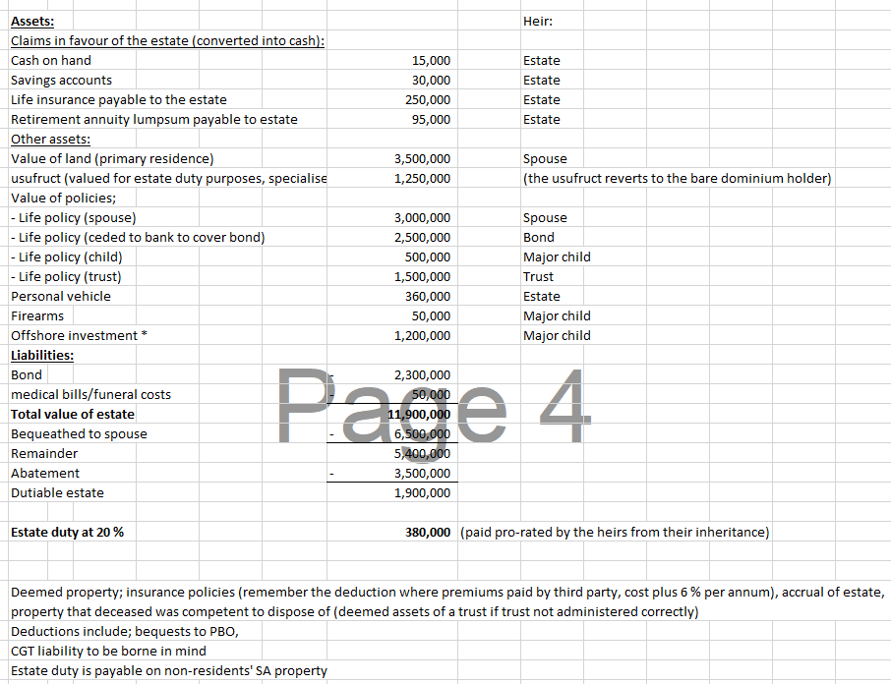

# **WHAT YOU NEED TO DO:**

* Keep a copy of your Will with your personal papers, indicating where the original is kept (The Masters office needs the original Will when winding up the deceased estate).
* Review your Will from time to time and consider the above information.

# **WHAT YOUR RELATIVES SHOULD KNOW:**

* Your wishes regarding funeral arrangements – see attachment.
* Who to contact regarding organ donations (your family doctor should also be informed of this).
* Who the executor is so that they can lodge the necessary documents with the Master of the High Court (must be notified within 14 days).
* Accounts that need to be serviced so that services are not suspended (rates/elec/tele/etc.).
* No action regarding assets should be taken before consulting with the executor.
* Notify employer or pension fund asap to ensure prompt processing of benefits.

*Note: your will is a confidential document and you need not disclose its terms to anyone, except as indicated above.*

# **CHECKLIST OF DOCUMENTS TO KEEP TOGETHER WITH YOUR WILL**

|  |  |  |
| --- | --- | --- |
| 1 | Copy of the will, with note of where original will is kept (ACS can keep the original in safe at ACS offices) |  |
| 2 | Living will, if applicable |  |
| 3 | Power of attorney, if applicable |  |
| 4 | Title deeds of all properties, ensuring windeed search agrees to these deeds |  |
| 5 | Updated portfolio summary (obtain from your broker) of all policies and investments |  |
| 6 | Clear copies of ID documents, drivers' licences and passports |  |
| 7 | funeral arrangement details |  |
| 8 | security codes/login details (this can be on an encrypted document that trusted members have code for) |  |
| 9 | birth certificates |  |
| 10 | Vehicle registration papers |  |
| 11 | marriage certificate |  |
| 12 | antenuptial contract |  |
| 13 | inventory of home furnishings/personal effects |  |
| 14 | Firearm licences |  |
| 15 | shares/members' interest agreements |  |
| 16 | beneficiary agreements |  |
| 17 | buy and sell agreement |  |
| 18 | divorce and maintenance orders |  |
| 19 | copy of trust deeds and letters of authority/endorsements |  |
| 20 | list of banking details for group (bank, branch, name, account number) |  |
| 21 | group life, pension/provident/retirement annuity fund details (should be under the updated portfolio summary) |  |
| 22 | safe deposit boxes details |  |
| 23 | profit share agreements |  |
| 24 | accident insurance details (should be under the updated portfolio summary) |  |
| 25 | medical aid details |  |
| 26 | income tax numbers |  |
| 27 | Schematic of group structure |  |
| 28 | location of spare keys/firearms |  |
| 29 | latest financial statements of all entities in the group |  |
| 30 | Capital Gain Tax valuations |  |
| 31 | contact details of accountant/tax practitioner/attorney/advisor |  |
| 32 | Investments - list of investments |  |
| 33 | Asset HP agreements |  |
| 34 | bond agreement |  |
| 35 | lease agreements for rented properties |  |
| 36 | acknowledgement of debt |  |
| 37 | existing suretyships |  |
| 38 | any other relevant information |  |

# **FUNERAL DETAILS**

What hymns would you like?

_______________________________________________________________

_______________________________________________________________

_______________________________________________________________

What readings would you like?

_______________________________________________________________

_______________________________________________________________

Would you like communion? Yes / No

Cremation or Burial _____________________

Address of cemetery:

________________________________________________________________

If cremation, where are the ashes to be interred?

_________________________________________________________________

Other:

Person you would like to conduct the service: ____________________________________

If no flowers, where would you like donations to go? _______________________________

Which undertaker to use? ________________________________________

Special requests? ______________________________________________________________

_____________________________________________________________________________

_____________________________________________________________________________